JAVA MINI PROJECT
Name: Harman Saini
Prn: 24070521056
Sem: 4th A
Topic: Student Management System

1. Student Management System
Problem Definition:
Write a Java program that demonstrates inheritance by managing student data.
First, create a superclass named Person that contains general attributes like name and age.
Then, create a subclass called Student that inherits from Person and adds specific details such as roll number and marks.
Further, extend the Student class into another subclass named GraduateStudent, which includes additional information like specialization.
Finally, the program should display all the details of the graduate student by utilizing inherited properties from the parent classes.

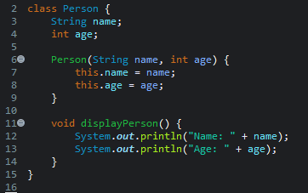
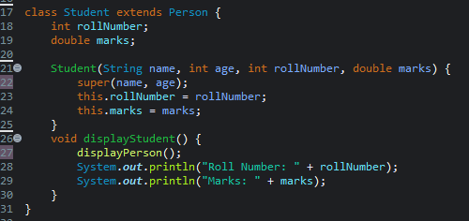
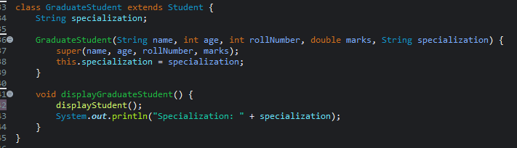

OUTPUT:
